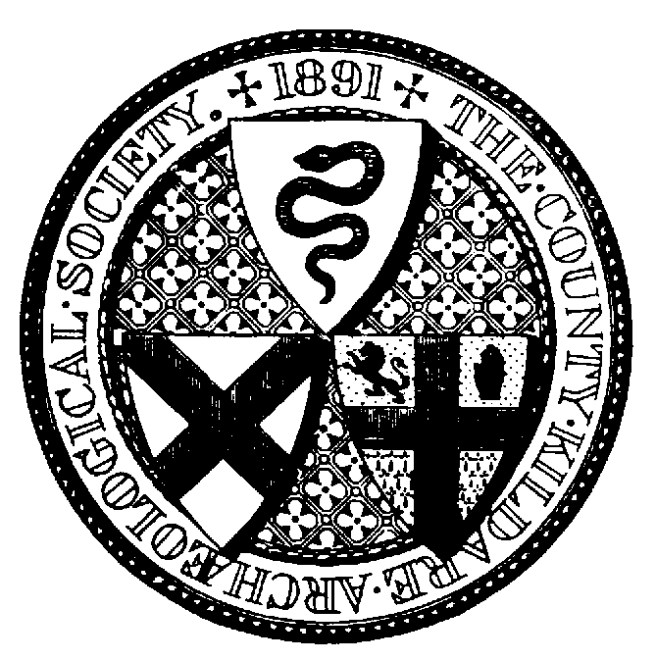

Talk on Lord Walter FitzGerald on the
100th Anniversary of his death
Monday 31 July at 7.30 pm
Venue: the de Lacey Suite, Kilkea Castle
Booking Form

Name ___________________________________________________________

Address _________________________________________________________

________________________________ Eircode _________________________

Mobile no:____________________ email:______________________________

Excursion: ______ place/s

tea/coffee: _______ place/s @ €5.50 per person

I enclose payment of € _______

Please send cheques or manual payments and booking form, with copy of SEPA payment if applicable to Siobhán McNulty, at the above address.

Cheques should be made out to ‘County Kildare Archaeological Society’. For SEPA Credit Transfers, in narrative please state ‘Kilkea’ followed by your name. IBAN IE10 AIBK 9335 0302 3241 54 BIC Code: AIBK IE2D.

County Kildare Archaeological Society

President
Siobhán McNulty
83 The Elms
NEWBRIDGE
Co Kildare
W12 XT20

