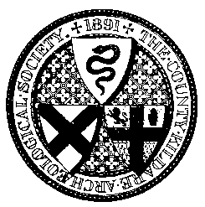 | County Kildare Archaeological Society _______
Honorary Membership Secretary: Greg Connelly Newington House Christianstown
Newbridge
Co Kildare
W12 TW60
Tel: 087 2555783

Emai: ckasmembers@gmail.com

Membership Renewal/Application – 2022

Name ___________________________________________________________

Address ___________________________________________________________

___________________________________________________________

EIRCode: _________________________

Tel no: _________________________

e-mail: _________________________

Subscription enclosed: € ____________

Annual Subscription Rates 2021. Single - €30; Joint - €40; Student - €15
Cheques should be made payable to ‘County Kildare Archaeological Society’. Please return this form and your subscription to the Honorary Membership secretary, Greg Connelly, at the above address. For SEPA Credit Transfers include an identifiable narrative i.e. name. IBAN IE10AIBK93350302324154 BIC Code: AIBKIE2D

