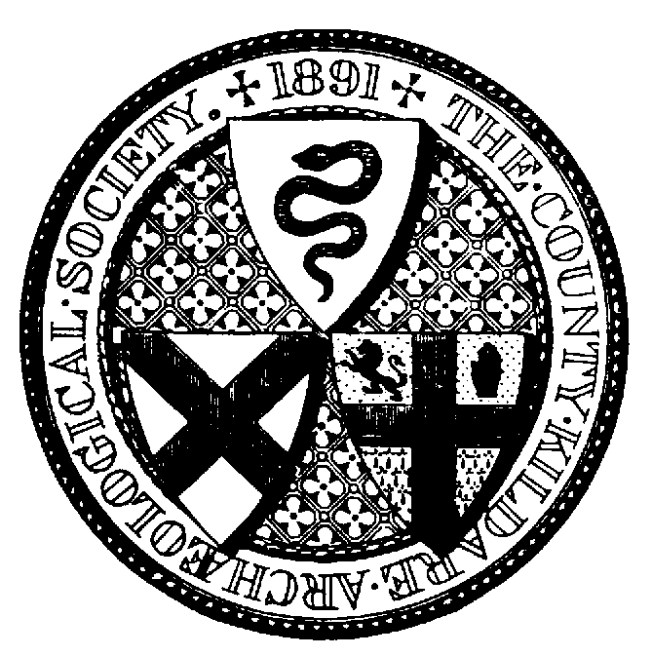

Annual Excursion - County Laois: Sunday 7th July 2013
Booking Form (Members only)

Name

Address

Tel no: email:

Excursion: place/s @ €20 per person

Dinner: place/s @ €25 per person

I enclose payment of €

Please send your booking form and payment to Mary Kirby at the above address by 25th June at the latest. Your tickets and further details will be posted to you. Cheques should be made payable to ‘County Kildare Archaeological Society’.

County Kildare Archaeological Society

Honorary Programme Coordinator
Mary Kirby
Holm Wood
Barrettstown
Newbridge
Co Kildare
045 449926

